PIZZA SALES SQL QUERIES

**A. KPI’s**

**1. Total Revenue:**

**SELECT SUM(total_price) AS Total_Revenue FROM pizza_sales**

2. Average Order Value:

SELECT (SUM(total_price)/COUNT(DISTINCT order_id)) AS Average_Order_Value

FROM pizza_sales

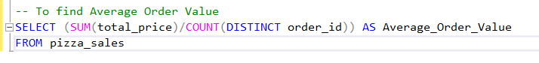

3. Total Pizza Sold

SELECT SUM(quantity) AS Total_Pizza_Sold

FROM pizza_sales

4.Total Orders

SELECT COUNT(DISTINCT order_id) AS Total_Orders

From pizza_sales

5. Average Pizza per Order

2.CHARTS

1.Daily Trends of Orders

2. Monthly Trends of Orders

3. Percentage of Sales by Pizza Category

---Note if we want to filter it for single month eg.january

4. Sales Percentage by Pizza Size

-To see at quarter level

5. TOP 5 Pizza by Total_Revenue

6.Bottom 5 PPizza by Revenue

7. Top 5 best seller pizza by quantity

8. Bottom 5 Pizza by quantity

9. TOP 5 Pizza by Orders

10.Bottom 5 Pizza by Orders

